
School: ............................................................................................................. Campus: ....................................................... Academic Year: ...................... Subject Name: ........................................................... Subject Code: ..........................
Semester: ............... Program: ........................................ Branch: ......................... Specialization: .......................... Date: .....................................
(Learning by Doing and Discovery)
* Coding Phase: Pseudo Code / Flow Chart / Algorithm
Hash your First Block

Introduction to Blockchain

Blockchain is a type of distributed, peer-to-peer ledger that is secured using cryptography. It functions as an append-only record, meaning data can only be added, not removed, and altering past records is highly difficult. Updates to the ledger occur only when there is consensus or agreement among the network participants.

Key Features of Blockchain

- Decentralization
– No single authority controls the network; data is shared among all participants.
- Immutability
- Once recorded, data cannot be modified or deleted.
- Transparency
– All participants can view the transactions recorded on the blockchain.
- Smart Contracts
– Self-running programs that execute predefined actions when certain conditions are met.
- High Security
– Strong cryptographic methods protect data from tampering.
- Consensus Protocols
– Mechanisms that help network participants agree on the validity of transactions.
- Distributed Ledger
– A synchronized record of transactions maintained across multiple locations.
- Privacy & Anonymity
– Users can interact without revealing their true identities while keeping data secure.

Blockchain Architecture Overview

A blockchain system is made up of several main components:
- Nodes – These are devices or computers that connect to and take part in the blockchain network.
- Blocks – Collections of validated transactions grouped together and added to the blockchain in order, with each block permanently linked to the previous one.
- Consensus Mechanisms – Algorithms or protocols that allow nodes to reach agreement on the state of the blockchain and verify transactions.
  - Common examples include:
    - Proof of Work (PoW)
    - Proof of Stake (PoS)
- Smart Contracts – Digital agreements that automatically execute when predefined terms are satisfied, removing the need for intermediaries.
- Cryptographic Protection – Security measures like hashing and digital signatures that make transactions resistant to alteration and ensure transparency.
- Networking & Protocols – The communication rules and systems that enable nodes to share information and validate data within the blockchain network.

Building the First Block (Genesis Block)

- Set the Initial Data
For the very first block in the chain, include some starting information — this could be a simple message or an initial transaction record.

- Prepare the Block Header
Fill in the header details. Since there is no block before this one, the “previous block hash” field will either be blank or set to a fixed default value.

- Generate the Block Hash
Use a cryptographic hashing algorithm (such as SHA-256) on the block’s complete contents (both header and data) to produce its unique hash value.
Keep creating new blocks by repeating the same steps — define the data, prepare the header, compute the hash, and connect it to the hash of the preceding block — until the blockchain grows as needed.

Coding Phase: Pseudo Code / Flow Chart / Algorithm

* Softwares used
Brave Browser

- Testing Phase: Compilation of Code (error detection)
1.1st Block ,no Modification
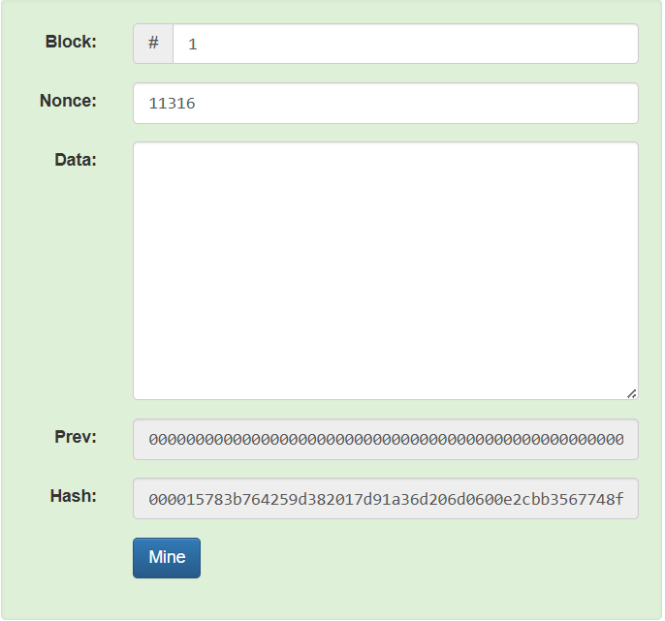

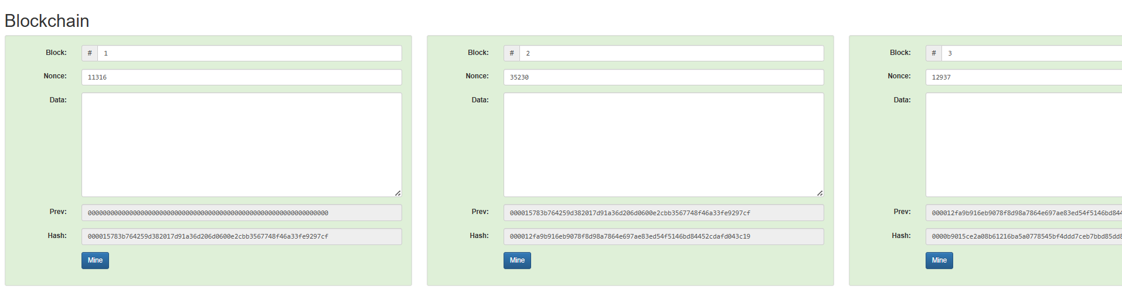

2.Data Inserted in First Block
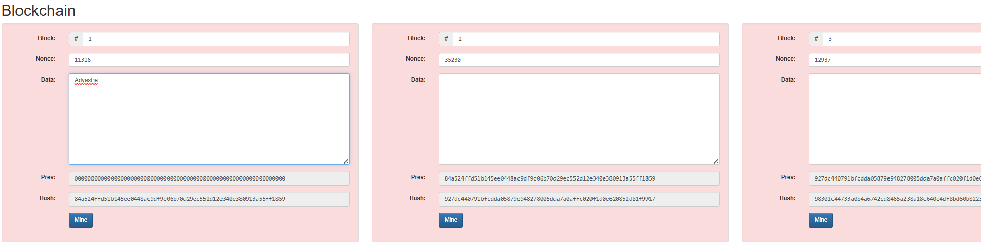

3.First Block get mined
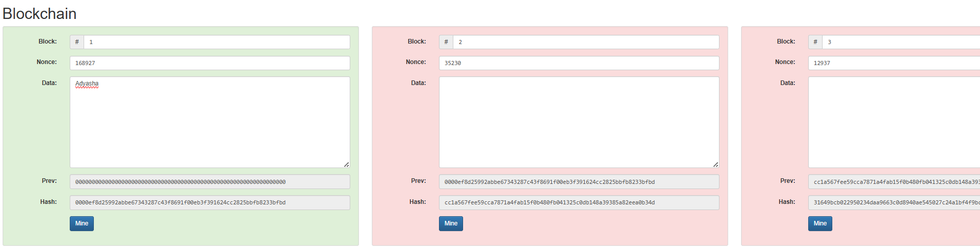

4.Data inserted and all mined
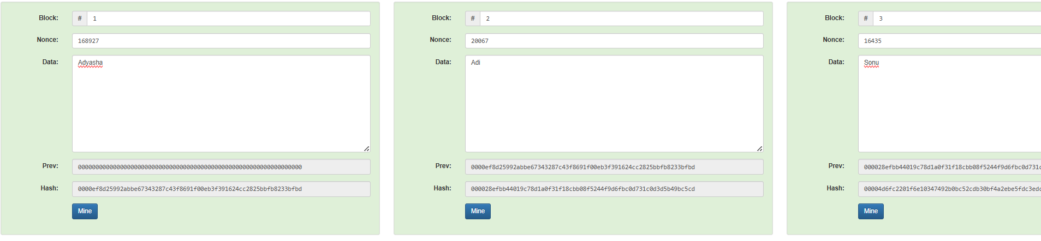

- Implementation Phase: Final Output (no error)

Implementation Phase: Final Output (no error)

- Implementation Phase: Final Output (no error)
Applied and Action Learning

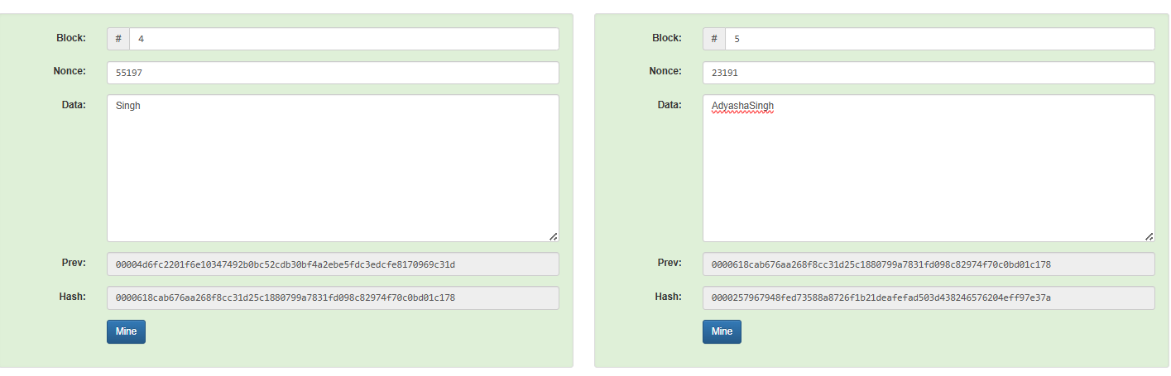
Final Output

* Observations
      - Each block holds transaction data, the time it was created, and the hash value of the block that came before it.
      - The process of hashing guarantees that the stored information remains intact and cannot be altered.
      - A hash function always produces the same output for the same input, but it is a one-way process — the original input cannot be reconstructed from the hash.
      - The overall security of a blockchain relies heavily on the use of cryptographic hashing.

ASSESMENT

Rubrics
Concept | 10
Planning and Execution/  Practical Simulation/ Programming | 10
Result and Interpretation | 10
Record of Applied and Action Learning | 10
Viva | 10
Total | 50


Signature of the Student:
Signature of the Faculty:

